1. Vagrant up 3 vms (mysql, back, front)
2. Open chrome and link url : “ <http://192.168.56.5:5000/> (front end)

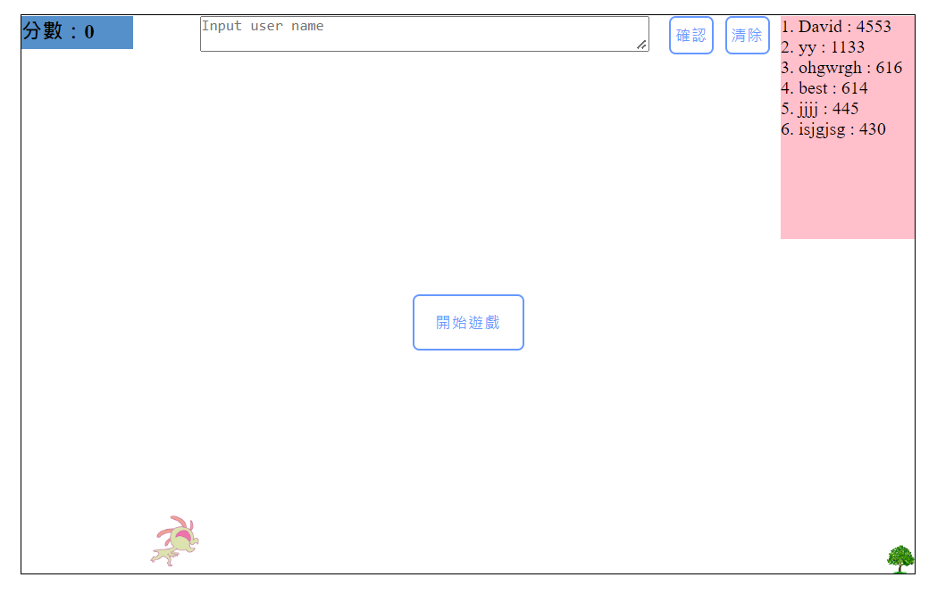

1. Game time:
   1. Click 開始遊戲 to start game.
   2. Press ‘Blank key’ to jump.
   3. If finish : insert ‘user name’ and click 確認.
   4. Click ‘重新開始’ to reload web.
   5. If want to clean DB, please click ‘清除’.

PS : if restart vms and stucked

### [Vagrant freezes on 'SSH auth method: private key'](https://github.com/hashicorp/vagrant/issues/11777)

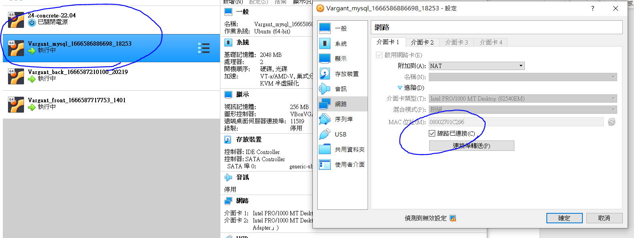

把vm 的設定裡面的網路裡面的線路以連接關掉重開按確定就可以跑了! 